
F O O T H I L L S

ANTIQUE POWER ASSOCIATION
ESTABLISHED 2003

Dear Members, December 2017
Merry Christmas to you all. It seems like it was only yesterday that we were making plans for the 2017 show. Now it is almost Christmas time and the New Year is approaching fast. We’ll soon be working hard on preparations for the 2018 show, but till then, enjoy the holidays.

- We continue to pray for those of our members, families, and friends who have special needs. Some have been on the list for some time now. We have received updates about some, but others we have heard nothing. When you speak with them, please let us all know how they are doing.

  - Put Troutman
  - Doug Carrigan
  - Dee Stewart
  - Reba Reinhardt
  - Jacqueline Hilliard
  - Ann Little
  - Carl Switzer
  - Brandon Bowman
  - Kelly Hicks
  - Sammie Scaer
  - Tammy Hoyle
  - Dale Haynes
  - Charles Bentley
  - Vee Williams
  - Wilson Sigmon
  - Lorna Sheets
  - Billie Sue Goforth
  - Steve Hefner
  - Vicki Hastings
  - Ira Cline
  - James Grant
  - Larry Sigmon
  - Kelly Blanton
  - Rev. Bobby Langston
  - Don Johnson
  - Carl Porter
  - Jane Abernathy
  - Kay Nash
  - Donnie Elmore

- We lost two faithful members this month. Henry Burns and Gary Setzer. They will both be missed.

- The Dec 7 meeting featured the drawings for the equipment to be featured on the 2018 Tee-shirt, program, and button. Congratulations to all who were selected.
  - Button: Larry Sigmon
  - Tee-shirt/program: Dylan Henline, Bryan Warner, Jason Gardner, Ken Isenhour, Casey Iverson, Doug Carrigan, and (alternate) Floyd Fowler. Final selection for tee-shirt or program will be made by the Show Committee.
  - Congratulations to you all. Please submit clear photographs of the equipment you choose as soon as possible so we can get the tee-shirt design started early and buttons ordered.

- January 18 will be the first Show Committee meeting of the new year. We know from past experience that, once we get started, it will be an all-out push to get everything ready in the short, few months’ time we have. We hope as many members as possible will be a part of the preparations. For all who are willing to come and help, thank you very much.

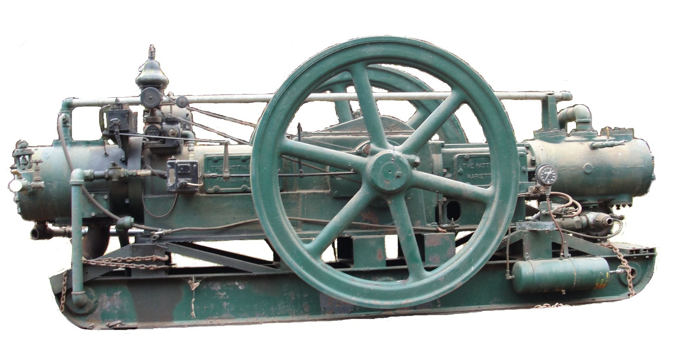

- Last month we were presented with the availability of purchasing a 120HP Fairbanks-Morse diesel engine and a 20HP Pattin Bros. oil-field compressor engine. Both purchases have been made. (This is a picture of the Patton Bros. engine.)
  - If you want to see some photos, here’s a link: https://1drv.ms/f/s!Av6Bg3ugRdIQnh3H2EUFxVShT7qD
  - The compressor has already been transported from South Carolina and is awaiting placement at the fairgrounds.
  - The diesel engine will be moved from Dacusville, SC in the near future thanks to Keith Schronce.
  - Much work is yet to be done to get them both set in place at the fairgrounds, but we fully hope to have them operational by May.

- Brandon Sigmon has set up an account with REMIND Services. This service will be used (for those who are tech savvy) to send text message reminders for meetings and notices of upcoming events. If you want to be on the receiving end of these reminders (some of us need all the reminders we can get!), text @fapa2017 to #81010.

--- --- --- UP-COMING EVENTS --- --- ---

Dec 14 Riverbend FAPA Christmas party @ Keith Schronce’s
Dec 14 Maiden Maiden Christmas Festival
Dec 25 Christmas Day
Dec 31 New Year’s Eve
Jan 1 New Year’s Day
Jan 4 Sig’s January monthly meeting
Jan 18 Sig’s Show Committee meeting
Jan 17-20 Ft.Meade FL Flywheelers Swap Meet
Feb 1 Sig’s February monthly meeting
Feb 15 Sig’s Show Committee meeting
Feb 21-24 Ft.Meade FL Flywheelers Show

-- --- --- THE CLASSIFIEDS --- --- ---

Is there anything you would like to sell or are you looking for something special? List it here.
(Item listings will run for 3 months before expiring. Let us know when an item is sold or bought.)

FOR SALE

Cultivators for International 140; Glenn Bostian 828-459-7412. (1709)

AC CA wide front older repaint $2000; AC 200 $5000; AC D-19 Wide Front diesel $4750;
AC IB $1650; AC I400 with Loader $3650 – Wilson Sigmon (home) 828-256-2176, (cell) 828-320-1419 . (1709)

WANTED

God used tractor tire, 13.6-28 828-381-2188. (1712)

☺ ☺ !!!!! HAPPY BIRTHDAY !!!!! ☺ ☺

December Birthdays

1- Doug Hoyle

5 – Johnny Sigmon
5 – Vickie Harrison
9 – RD Lineberger
10 – Carroll Baker

13 – Lin Couch
14 – Mark Story
15 – Johnny Kistler
15 – Lynn Baker
22 – Ray Weaver
27 – Scott Minyard
27 – Dale Reese

January Birthdays

6 – Bill Harris
7 – Everette Blair
12 – Gene Harvell
21 – Mike Stewart
24 – Shannon Hedrick

President: Kevin Black 828-464-1950 Vice Pres: Wilson Sigmon 828-256-2176
Treasurer: Kermit Nash 828-459-9616 Secretary: David Setzer 828-850-4943
Show Chair: Teddy Hefner 828-310-5525 Asst. Show Chair: Anthony Austin 828-302-5326
Asst. Secretary: Kevin Sigmon 828-320-1419

Board of Directors: Phillip Spencer, Howard Reinhardt, Ned Story, Teddy Hefner, Tim Hollar, Butch McIntyre

Foothills Antique Power Association
5851 St. Peter’s Church Road, Conover, NC 28613 -
Foothillsantique.com

-- --- --- a thought for this time of year --- --- ---

“It’s the most wonderful time of the year”
So goes one of the songs we hear frequently between Thanksgiving Day and Christmas Day. Listen to the lyrics next time you hear it. Though it is a very good song with a catchy tune, it is apparent that the writer (and possibly even the singer also) has little knowledge of how wonderful, or rather, how wonder-full this time of year truly is.
That song, along with quite a few others, speaks of friends, family, parties, and good times, but it hints at nothing more. If that is all there is to it, what makes it so special. Without knowing the truth behind it, it is only a holiday from work, one that has many traditions associated with it, one that carries many expectations, whether they are realistic or not. If we stripped away all the trappings: the gifts, trees, lights, songs, even the day itself, most people would have nothing to celebrate.
But, do that for those of us who know the truth, we can and do celebrate. In fact, we can and do celebrate Christmas not just one day in a year, but every day, because we know that it is not just the celebration of the beginning of one life, but the celebration of life for all of us.
Jesus, God’s only begotten son, born in Bethlehem as God Himself promised, came to save his people from their sins. He did so, not as a great teacher, not as a healer or miracle worker, but by giving himself up to die – giving his life (a life not tainted by sin and thus underserving of death) as a pure, spotless sacrifice. His death was received by God as the payment to reconcile all mankind back to Him from the rule of sin and death and the power of the devil.
God received Jesus’ sacrifice and honored him by raising him from the dead to die no more. But that was not the end of it. He gave us life also in Christ – a life to be lived by faith, not because of who we are or what we have done, but simply because we believed what He said about His son.
Without God’s Word we would not know why Christmas is to be celebrated. Without God’s Word, we would have nothing to celebrate. Without God’s Word we have nothing wonder-full to sing about.
God bless you all.
We’ll see you next year.
Your Secretary, David Setzer



